[Array 14 (2022) 100141](https://doi.org/10.1016/j.array.2022.100141)

|  |  |  |
| --- | --- | --- |
|  |  |  |
|  | Contents lists available at ScienceDirect |  |
| Array |
| journal homepage: [www.sciencedirect.com/journal/array](https://www.sciencedirect.com/journal/array) |

Indian Sign Language recognition system using SURF with SVM and CNN Shagun Katocha, Varsha Singhb,*, Uma Shanker Tiwaryb   
a *Computer Science, National Institute of Technology, Hamirpur, India*   
b *Department of Information Technology, Indian Institute of Information Technology, Allahabad, India*

|  |  |
| --- | --- |
| A R T I C L E I N F O | A B S T R A C T |
| *Keywords:*  Hand sign recognition  Indian sign language (ISL) Bag of visual words (BOVW) SURF features  SVM  CNN  Pyttsx3  Google speech API | Hand signs are an effective form of human-to-human communication that has a number of possible applications. Being a natural means of interaction, they are commonly used for communication purposes by speech impaired people worldwide. In fact, about one percent of the Indian population belongs to this category. This is the key reason why it would have a huge beneficial effect on these individuals to incorporate a framework that would understand Indian Sign Language. In this paper, we present a technique that uses the Bag of Visual Words model (BOVW) to recognize Indian sign language alphabets (A-Z) and digits (0–9) in a live video stream and output the predicted labels in the form of text as well as speech. Segmentation is done based on skin colour as well as background subtraction. SURF (Speeded Up Robust Features) features have been extracted from the images and histograms are generated to map the signs with corresponding labels. The Support Vector Machine (SVM) and Convolutional Neural Networks (CNN) are used for classification. An interactive Graphical User Interface (GUI) is also developed for easy access. |

**1. Introduction**

Communication has always played a vital role in human life. The calibre to interact with others and express ourselves is a basic human necessity. However, based on our upbringing, education, society, and so on, our perspective and the way we communicate with others can differ to a great extent from those around us. In addition to this, ensuring that we are understood in the way we intend, plays a very important role.

Despite this fact, normal human beings do not have much difficulty interacting with each other and can express themselves easily through speech, gestures, body language, reading, writing, speech being widely used among them. However, people affected by speech impairment rely only on sign language, which makes it more difficult for them to communicate with the remainder of the majority. This implies a requirement for sign language recognizers which can recognize and convert sign language into spoken or written language and vice versa. Such identifiers, however, are limited, costly, and cumbersome to use. Now, researchers from different countries are working on these sign language recognizers, which is the main reason behind the development of automatic sign language recognition systems.

Notwithstanding that India is a diverse country having nearly 17.7% of the world’s population residing here, but very limited work has been done in this research area, which is quite contradictory as compared to

* Corresponding author.

*E-mail address:* [varshagaur@gmail.com](mailto:varshagaur@gmail.com) (V. Singh).

the other countries [1–3]. Delayed standardisation can be attributed to the evidence for this. Indian Sign Language studies began in India in 1978. But since no standard type of ISL existed, its use was restricted to short-term courses only. In addition, the gestures used in most of the deaf schools varied significantly from each other and nearly 5% of the total deaf people attended these schools. It was in 2003 when ISL got standardized and grabbed the attention of researchers [4].

Indian Sign Language (ISL) involves both static and dynamic signs, single as well as double-handed signs, and in different regions of India, there are many signs for the same alphabet. It makes it very difficult to introduce such a scheme. In addition, no standard dataset is available.

All these things manifest the complexity of Indian sign language.

Recently, researchers have started exploring this area. There are mainly two different approaches widely used in sign language recogni-tion: Sensor-based approach and Vision-based approach [5]. The sensor-based approach uses gloves or other instruments that recognize finger gestures and translate them into equivalent electrical signals for sign determination, whereas web cameras are used to capture video or images in a vision-based approach. Due to its no specialised hardware requirement, the vision-based gesture recognition offers the advantage of being spontaneous, and is favoured by the signers [6]. However, hand segmentation in a complex setting, which plays an important role in identification. A framework that can overcome this problem is therefore

<https://doi.org/10.1016/j.array.2022.100141>   
[Received 11 September 2021; Received in rev](https://doi.org/10.1016/j.array.2022.100141)ised form 10 January 2022; Accepted 29 March 2022   
Available online 14 April 2022   
2590-0056/© 2022 Published by Elsevier Inc. This is an open access article under the CC BY license (<http://creativecommons.org/licenses/by/4.0/>).

*S. Katoch et al.*  *Array 14 (2022) 100141*

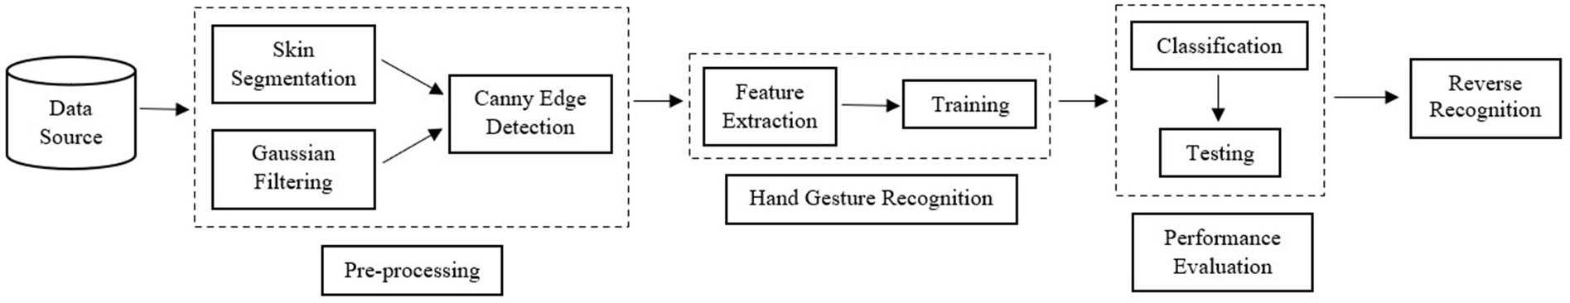

**Fig. 1.** Flow Diagram of the proposed approach.

suggested.

The advances in machine learning and deep learning technology are providing new methods and algorithms for recognizing Indian sign language alphabets efficiently, accurately and inexpensively. The end- to-end auto run of these models overcomes the highly subjective and inconsistent limitations of traditional methods, improving accuracy and efficiency of the results.

In this work, the authors present a methodology to build a large, assorted and robust real-time alphabets (A-Z) and digits (0–9) recogni-tion system for Indian Sign Language. Instead of using high-end tech-nologies like gloves or the Kinect, here authors have recognised signs from images (which are accessed from a webcam). The accuracy ob-tained in the result is also discussed in this paper. The real-time, accurate and efficient judgement on ISL sign recognition is required to bridge the communication gap between the abled and the hearing or speech impaired people.

**2. Related works**

Depending on the nature of sign language and the signs, different authors have employed different methodologies.

*J. Singha* et al. [7] proposed a method for real time recognition where Eigen value-weighted Euclidean distance was used to classify signs. *P. Kishore* et al. [8] proposed a system by finding active contours from boundary edge map using Artificial Neural Network (ANN) to classify the signs. Another approach used the Viola Jones algorithm with LBP functions for hand gesture recognition in a real-time environment [9]. It had the advantage of requiring less processing capacity to detect the movements. Segmentation is the primary and one of the most important steps in hand processing, in general Otsu’s algorithm gave a fairly high rate of accuracy [10]. In an attempt [11], moving block distance parameterization method was used to skip the initialization and seg-mentation steps. High precision static symbols and 33 basic word units were used.

Most of these works were based on pattern recognition, feature extraction, and so on [12]. However, in most of the cases, a system with single feature is not enough. Therefore, hybrid approaches were intro-duced to solve this problem. For eg, *A. Nandy* et al. [13] used hybrid approaches with K-Nearest Neighbor (KNN) and Euclidean distance to classify gestures from orientated histogram features. The limitation of this approach was the poor performance in case of similar gestures. *K Manjushree* et al. [14] used single handed sign classification with his-togram of oriented gradients and feature matching. *S. Kanade* et al. [15] designed a system with custom dataset using PCA features and SVM, and obtained good accuracy. *A. Sahoo* [16] proposed ISL recognition for both single and double handed character signs. *Geetha. M* et al. [17] used B-Spline approximation for the shape matching of static gestures of ISL alphabets & numerals. In Ref. [18], a method was proposed to classify word symbols using the Neuro-Fuzzy approach and natural language processing (NLP) technology to display the final word. *Q. Chen* et al. [19] proposed a method to recognize hand gestures using haar-like features and AdaBoost algorithm. They also described random context-free grammars to fully recognize gestures. The combination of PCA and the local coordinate system produced high calculation accuracy

2

*S. Katoch et al.*  *Array 14 (2022) 100141*

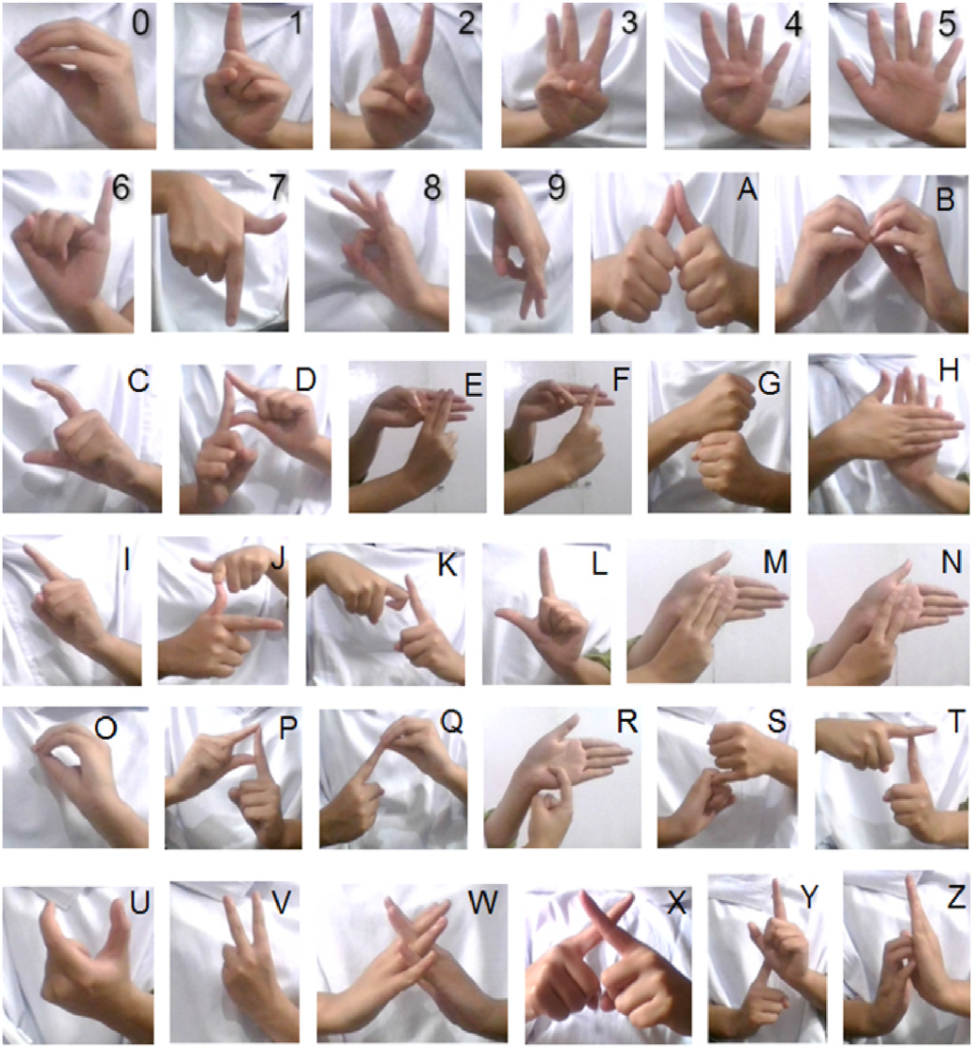

**Fig. 2.** Isl signs.

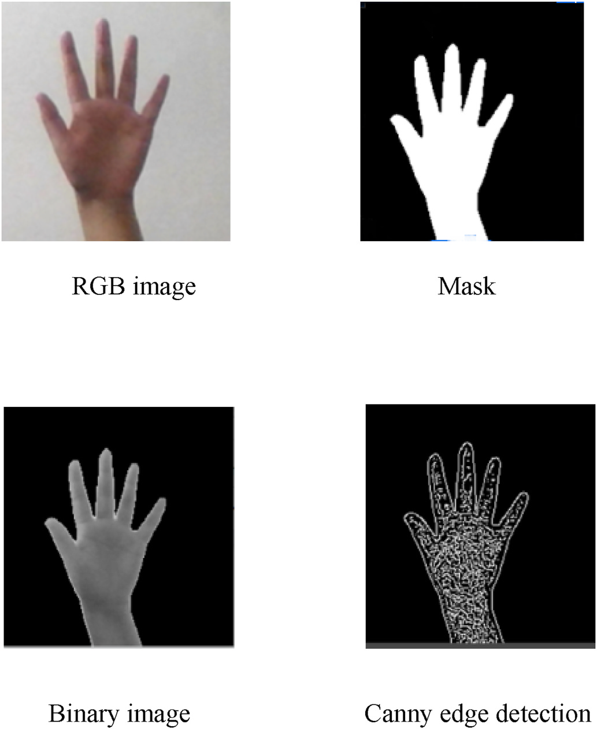

**Fig. 3.** Preprocessing steps.

thereby making the extraction process easier. The dataset was created by taking into account both of these approaches in order for the model to perform well in diverse scenarios.

The signs obtained from the live video were converted into frames,

3

*S. Katoch et al.*  *Array 14 (2022) 100141*

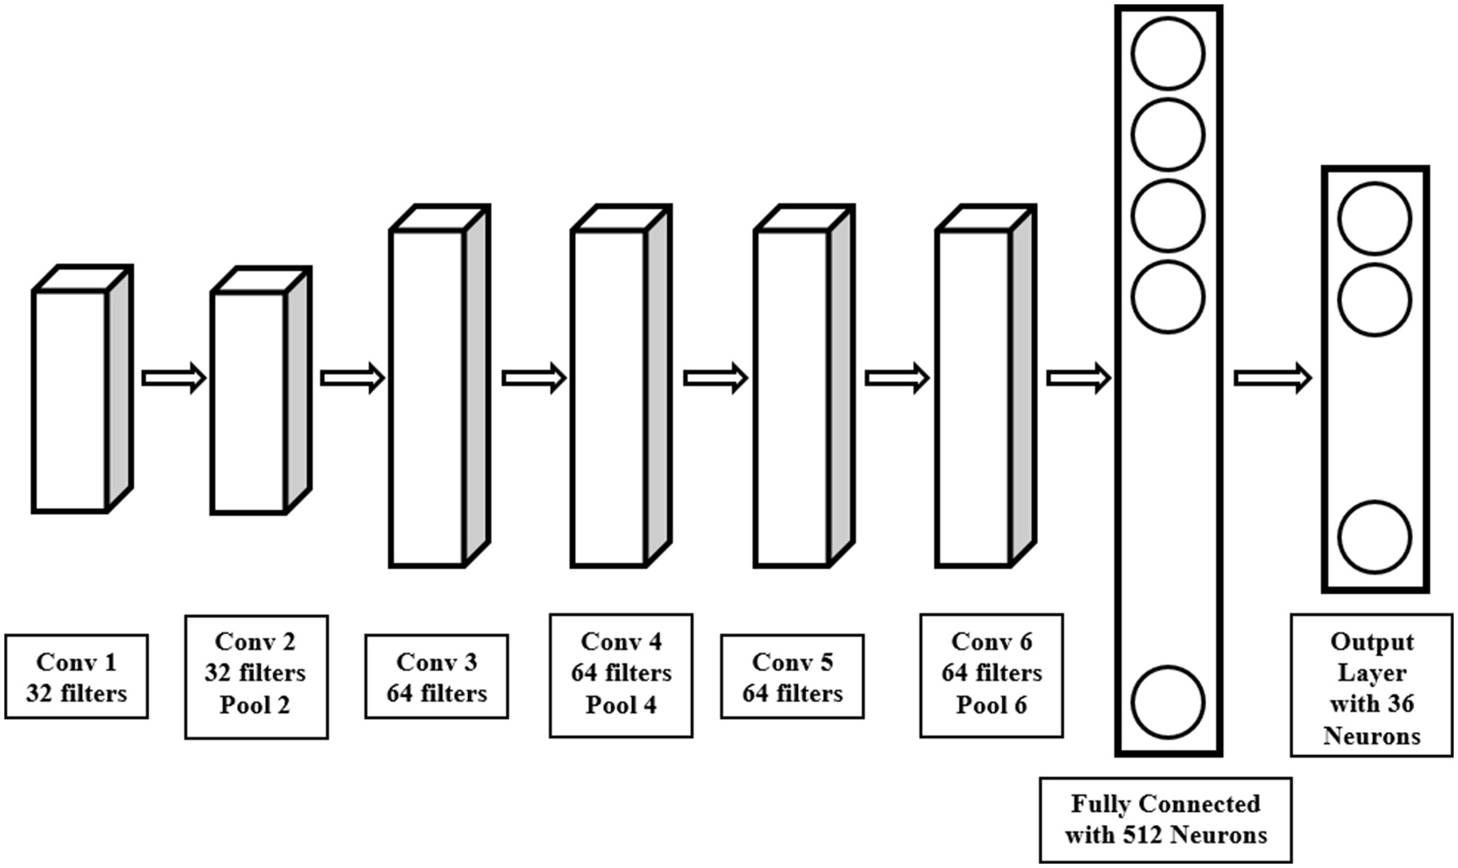

**Fig. 5.** CNN architecture.

**Table 1**   
Class wise accuracy table.

|  |  |  |  |  |  |  |  |  |
| --- | --- | --- | --- | --- | --- | --- | --- | --- |
| Label | SVM (%) | CNN (%) | Label | SVM (%) | CNN (%) | Label | SVM (%) | CNN  (%) |
| **0**  **1**  **2**  **3**  **4**  **5**  **6**  **7**  **8**  **9**  **A**  **B** | 100  99  98  96  100  100  100  100  98  98  100  100 | 100  100  100  98  100  99  100  100  100  100  100  100 | **C**  **D**  **E**  **F**  **G**  **H**  **I**  **J**  **K**  **L**  **M**  **N** | 100  100  96  95  98  100  98  100  100  99  100  99 | 100  100  97  100  100  100  100  100  100  100  99  100 | **O**  **P**  **Q**  **R**  **S**  **T**  **U**  **V**  **W**  **X**  **Y**  **Z** | 99  100  100  98  100  99  99  100  99  100  99  100 | 99  100  100  98  100  100  100  100  100  99  100  100 |

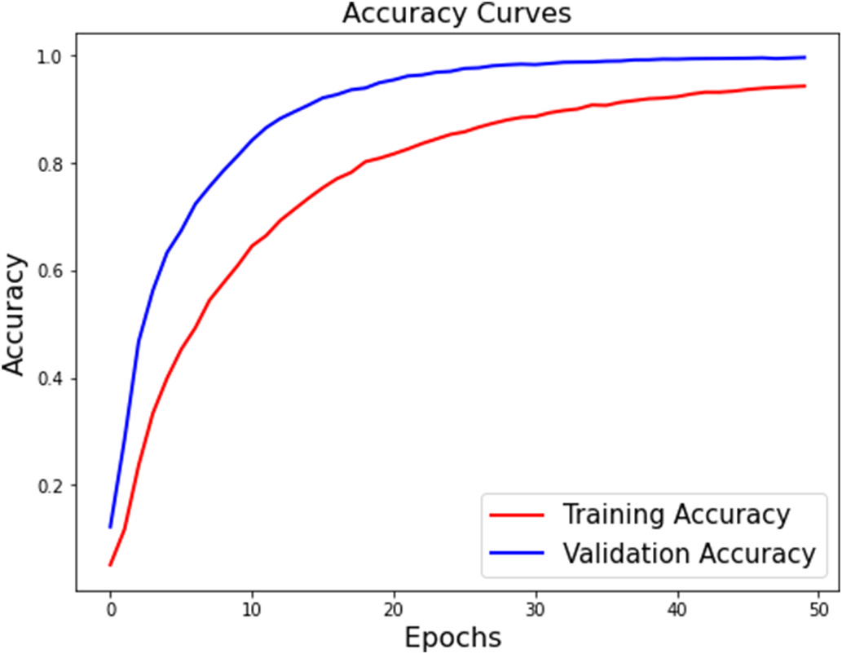

**Fig. 6.** Accuracy graph of CNN.

4

*S. Katoch et al.*  *Array 14 (2022) 100141*

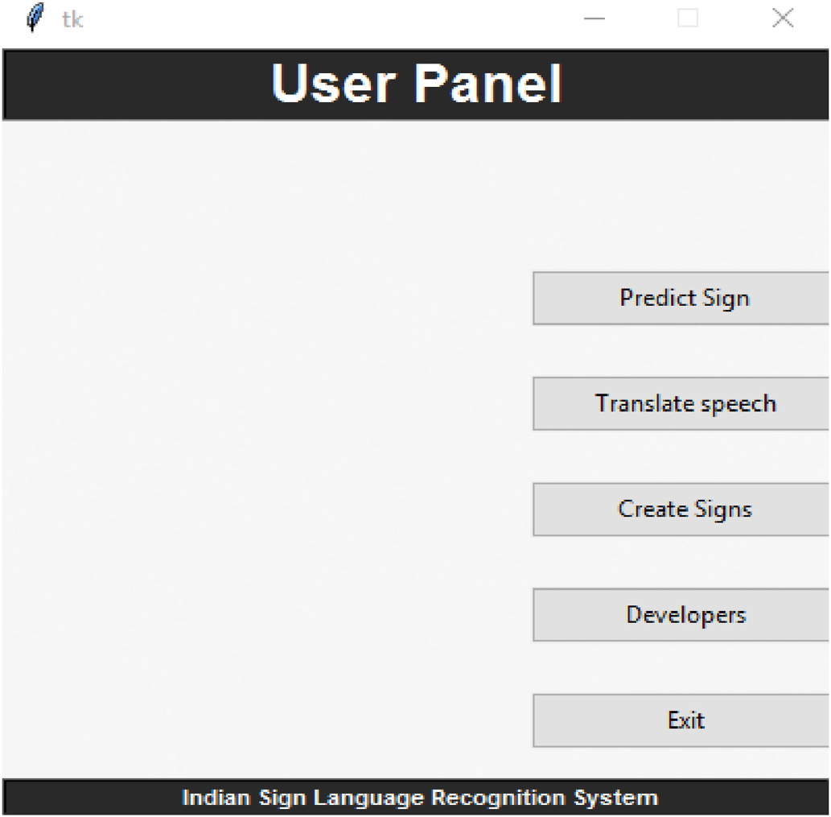

**Fig. 8.** System GUI.

image is represented as a frequency histogram of characteristics ob-tained, the image descriptors and key points are used. Later on, the category of another comparable image can be predicted from this fre-quency histogram.

As discussed, the first step in building a bag of visual words (BOVW) is to extract descriptors from each image in the dataset. The descriptor is a 64-member vector for each interest point in the execution used which defines the distribution of the intensity material within the neighbor-hood of the interest point. For this, SURF (Speeded Up Robust Features) [27] is used which is a local feature detector and descriptor. We have used SURF as they are robust against rotation, variance, point of view occlusion, and provide operators with box filters for fast computation.

An image is represented as a set of image descriptors given by SURF as Eq (1).

*Im* = {*d*1*, d*2*, d*3*,* ……………*dn*} (1)

where di is the colour, shape, etc. of the hands. and n denotes the total image descriptors. Fig. 4 shows the extracted SURF features when a binary image representing sign A is passed to the SURF.

The next step in the extraction of features is to cluster all the features that are obtained after the SURF is applied. This is done to group similar features so that it is possible to use the core and cluster them as the dictionary’s visual keyword. The clustering can be performed using the K-means algorithm, but we have used mini batch K-Means as the data is very large. It is comparable to K-means, but is better in terms of pro-cessing time and memory use. It utilises small random batches of fixed- size data at a time, thus reducing the need to have all the data in the memory at the same time. A new random sample from the dataset is obtained in each iteration and used to update the clusters, which is repeated until convergence. We have a value of k as 180 for this purpose.

For codebook generation, the resulting cluster centres (i.e., cen-troids) are treated as our code vectors. A codebook is used for quantizing features where it takes a feature vector as input and maps it to the index of the nearest code vector. The constructed vocabulary can be repre-sented as:

descriptor to the nearest visual word is done according to the Eq (3).

*w*(*d*) = *argmin Dist*(*w, d*) (3)

where w (di) depicts the visual word assigned to the ith descriptor and Dist (w,di) represents the distance between the visual word w and descriptor di.

The last step is the generation of the histograms for all the images which is done by calculating the frequency of occurrence of each visual word in an image. The count of bins in the histogram is equal to the total number of visual words in the dictionary i.e. k and is represented by Eq (4).

Here Di is the set of all the descry iptors corresponding to a particular *bini* = *C*(*Di*) Where *Di* = { *dj, jε*1*,* ……*n* ⃒⃒*w* ( *dj* ) = *wi* } (4)

visual word wi in the image and C (Di) is the cardinality representing the count of the elements in set Di. For every visual word in the image, this is repeated to obtain final histograms that are then passed for recognition to the classifier along with their respective labels.

*3.4. Classification*

We proceed to the classification stage once the feature detection and extraction process is finished. It involves classification using a Support Vector Machine (SVM) and using a Convolutional Neural Network (CNN).

*3.4.1. Support Vector Machine*   
 The Support Vector Machine (SVM) is a supervised model that can solve both linear and non-linear problems for classification and regres-sion problems. It operates on the idea of decision planes that specify boundaries for decisions.

For this classification, we have used SVM with a linear kernel. We have passed the histograms of visual words to the SVM as feature vectors for the classification and recognition of ISL signs. The training is done using a total of 28,800 images. After the training is completed, the performance of the classifier is checked on the testing set which has a total of 7236 images, and its performance is evaluated on various pa-rameters like accuracy, precision, recall, etc.

*3.4.2. Convolutional neural networks*   
 CNNs are functional extraction models inspired by the human brain’s visual cortex. CNNs compare images piece by piece where a filter map slides over the local patches of the image. Such pieces are called fea-tures, and they compare two images by finding approximately the same features at approximately the same locations. CNNs have a better ability to see images and classify them than other neural networks.

Our general architecture is a fairly common CNN architecture, con-sisting of multiple convolutional and dense layers. Each CNN is 3 layers deep. The architecture starts with a group of 2 convolutional layers which have 32 filters with a window size of 3 × 3 followed by a max- pool layer and a dropout layer. It is then followed by another group of 2 convolutional layers with 64 filters, a max pooling layer and dropout layer. Further, there are another 2 convolutional layers with 64 filters and a max pooling layer and at the end, there is a fully connected hidden layer with 512 neurons of the ReLU activation function and an output layer of the softmax activation function. The first convolution layer takes an input image of size (100,100) whereas the final output layer consists of 36 neurons corresponding to each category of the ISL signs. The architecture diagram for the same is shown in Fig. 5.

|  |  |  |
| --- | --- | --- |
| *v* = {*w*1*, w*2*, w*3*,* ……………*wk*} | (2) | *3.5. Output sign* |

where k is the total number of clusters i.e. 180. The mapping of each

5

*S. Katoch et al.*  *Array 14 (2022) 100141*

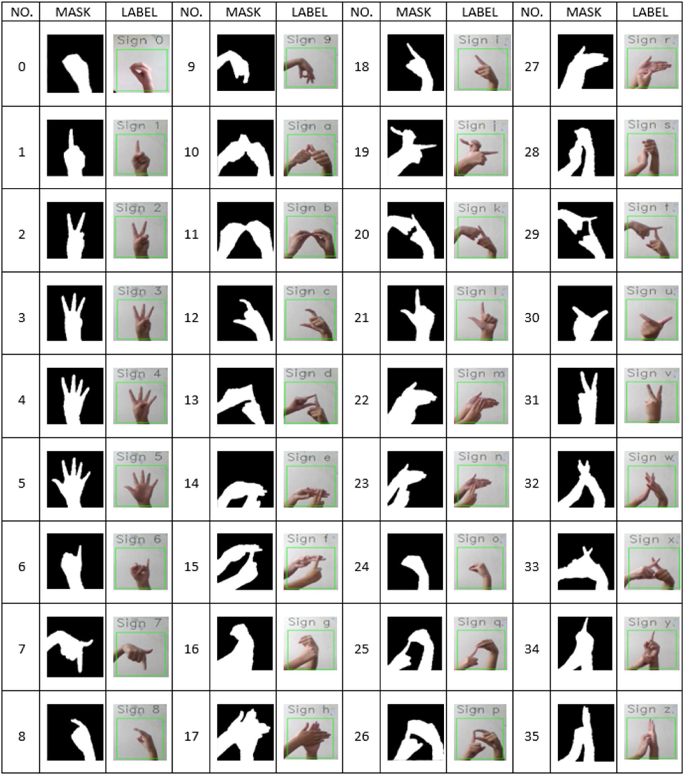

**Fig. 9.** Snapshots of the proposed system.

This is done to provide better communication and ease to the user. Once the label is identified by the classifier, it is passed to a dictionary as a key which returns the corresponding sign as value. This is then shown to the user. For text to speech conversion, python text to speech module, Pyttsx3 is used. As it causes a delay in the live video stream by making the frames process at a very slow rate, threading is performed. Due to this, the prediction of signs and the translation of text to speech can be achieved at the same time. This ensures that the sound is played continuously, without any disturbance.

*3.6. Reverse recognition*

The reverse process is essential in a sign language recognition system

6

*S. Katoch et al.*  *Array 14 (2022) 100141*

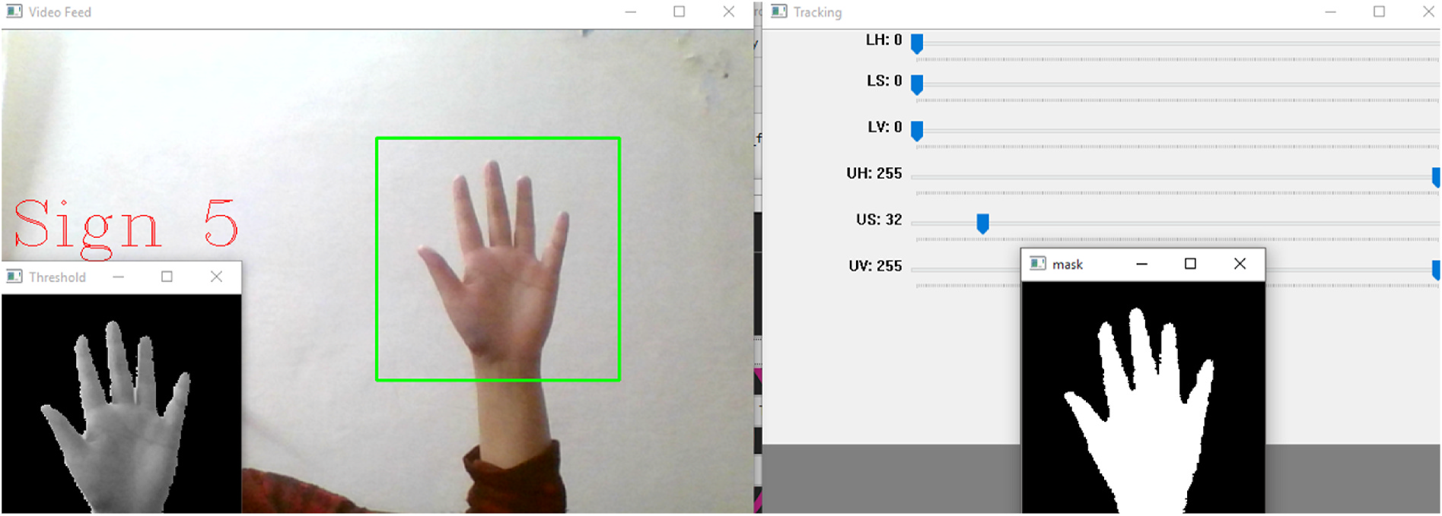

**Fig. 10.** Real time testing.

**Table 4**   
Comparison table.

|  |  |  |
| --- | --- | --- |
| Dataset | Models Used | Accuracy |

the total observations which are positive. The recall is the ratio of correctly predicted positive labels to the total no. of labels which are positive whereas the F1 score is the weighted average of precision and recall. The results can be seen in Table 3.

|  |  |  |  |  |
| --- | --- | --- | --- | --- |
| Single Handed Dataset | SVM + HOG features | 97.1% | *Precision* | *TP* |
| Single + Double Handed dataset with variations | SVM  CNN | 99.17% 99.64% | = | *TP* + *FP* |

CNN has performed better with a lesser no. of features. The system is trained to recognize 36 signs (26 alphabets and 10 numerals). Current results are promising, keeping in mind that few improvements could provide better results.

|  |  |
| --- | --- |
| *Recall* | *TP* |
| = | *TP* + *FN* |
| *F*1 *Score* =2*(*Recall*\**Precision*) *Recall* + *Precision* | |

*4.1. SVM performance*  *4.4. Real Time Testing*

SVM has given an accuracy of 99.14% on the test data. The calcu-lated values of precision and recall of alphabets and digits classified using SVM show an overall accuracy of 99%. The class wise accuracy can be seen in Table 1.

*4.2. CNN performance*

Using CNN, we have observed an overall accuracy of 94% on the training set on the last epoch whereas a testing accuracy greater than 99%. The total epochs are 50. We have trained our model with a cate-gorical cross entropy loss function and softmax function as the activation function, which has given a training loss of 0.1748 on the last epoch and a testing loss of 0.0184. The class wise accuracy can be seen in Table 1. The accuracy graph for our experiment is shown in Fig. 6 whereas the loss graph can be seen in Fig. 7.

*4.3. Quantitative analysis*

*4.3.1. Accuracy*   
 Accuracy is the most innate performance measure and is simply a ratio of correctly predicted observations to the total observations. In terms of true positives (TP), true negatives (TN), false positives (FP) and false negatives (FN), the formula of the accuracy can be written as-

|  |
| --- |
| *Accuracy* = *TP* + *FP* + *FN* + *TN TP* + *TN*  The comparison of test accuracies of both the classifiers is done in  Table 2. Both the classifiers have performed well on the test data with  accuracies greater than 99%. |

*4.3.2. Performance metrics*   
 Precision is the ratio of correctly predicted positive observations to

7

*S. Katoch et al.*  *Array 14 (2022) 100141*

The main goal of our work is to provide a more real-time recognition utility so that the system can be used anywhere. It is achieved by con-structing a custom data set, making the system invariant to rotation and solving the background dependency problem. The system is successfully trained on all 36 ISL static alphabets and digits with an accuracy of 99%. In future, the dataset can be expanded by adding more signs from different language of various countries, thereby achieving a more effective framework for real-time applications. The method can be extended for the formation of simple words and expressions for both continuous and isolated recognition tasks. The secret to true real-time applications is enhancing the response time.

**Credit author statement**

**Shagun Katoch**: Methodology, Software, Investigation, Data cura-tion, Writing – original draft. **Varsha Singh**: Conceptualization, Visu-alization, Validation, Formal analysis, Resources, Project Management, Writing- Reviewing and Editing. **Uma Shanker Tiwary**: Supervision

**Declaration of competing interest**

The authors declare that they have no known competing financial interests or personal relationships that could have appeared to influence the work reported in this paper.

**References**

[1] [Bantupalli Kshitij, Xie Ying. American sign language recognition using machine](http://refhub.elsevier.com/S2590-0056(22)00012-1/sref35) [learning and computer vision. Master of Science in Computer Science Theses 2019;](http://refhub.elsevier.com/S2590-0056(22)00012-1/sref35) [21.](http://refhub.elsevier.com/S2590-0056(22)00012-1/sref35)

[2] [Sh](http://refhub.elsevier.com/S2590-0056(22)00012-1/sref35)adman Shahriar, Ashraf Siddiquee, Tanveerul Islam, Abesh Ghosh, Rajat Chakraborty, Asir Intisar Khan, Celia Shahnaz and Shaikh Anowarul Fattah. Real- time American sign language recognition using skin segmentation and image category classification with convolutional neural network and deep learning. In TENCON, IEEE Region 10 International Conference.

[3] [Shivashankara S, Srinath S. A comparative study of various techniques and](http://refhub.elsevier.com/S2590-0056(22)00012-1/sref38) [outcomes of recognizing American sign language: a review. In: International](http://refhub.elsevier.com/S2590-0056(22)00012-1/sref38) [Journal of Scientific Research Engineering](http://refhub.elsevier.com/S2590-0056(22)00012-1/sref38) [& Technology (IJSRET); 2017.](http://refhub.elsevier.com/S2590-0056(22)00012-1/sref38) *[ISSN](http://refhub.elsevier.com/S2590-0056(22)00012-1/sref38) [2278](http://refhub.elsevier.com/S2590-0056(22)00012-1/sref38)* [–](http://refhub.elsevier.com/S2590-0056(22)00012-1/sref38) *[0882. 6(9)](http://refhub.elsevier.com/S2590-0056(22)00012-1/sref38)*[.](http://refhub.elsevier.com/S2590-0056(22)00012-1/sref38)

[4] [Viswanathan Dale](http://refhub.elsevier.com/S2590-0056(22)00012-1/sref38)[esha M, Idicula Sumam Mary. Recent developments in Indian](http://refhub.elsevier.com/S2590-0056(22)00012-1/sref16) [sign language recognition: an analysis. Int J Comput Sci Inf Technol 2015;6(1):](http://refhub.elsevier.com/S2590-0056(22)00012-1/sref16) [289–93.](http://refhub.elsevier.com/S2590-0056(22)00012-1/sref16)

[5] [Nair An](http://refhub.elsevier.com/S2590-0056(22)00012-1/sref16)[uja V, Bindu V. A review on Indian sign language recognition. Int J Comput](http://refhub.elsevier.com/S2590-0056(22)00012-1/sref28) [Appl 2013;73(22).](http://refhub.elsevier.com/S2590-0056(22)00012-1/sref28)

[6] [Athira K, Sruthi C](http://refhub.elsevier.com/S2590-0056(22)00012-1/sref28)[J, Lijiya A. A signer independent sign language recognition with](http://refhub.elsevier.com/S2590-0056(22)00012-1/sref21) [Co-articulation elimination from live videos: an Indian scenario. J King Saud Univ](http://refhub.elsevier.com/S2590-0056(22)00012-1/sref21) [Comput Inf Sci 2022;34(3):771–8.](http://refhub.elsevier.com/S2590-0056(22)00012-1/sref21)

[7] [Singha J, Das K. Recognition of I](http://refhub.elsevier.com/S2590-0056(22)00012-1/sref21)[ndian sign language in live video. Int J Comput](http://refhub.elsevier.com/S2590-0056(22)00012-1/sref1) [Appl 2013;70(19):17–22.](http://refhub.elsevier.com/S2590-0056(22)00012-1/sref1)

[8] [Kishore PVV, Kumar DA.](http://refhub.elsevier.com/S2590-0056(22)00012-1/sref1) [Optical flow hand tracking and active contour hand shap](http://refhub.elsevier.com/S2590-0056(22)00012-1/sref2)e [features for continuous sign language recognition with artificial neural networks](http://refhub.elsevier.com/S2590-0056(22)00012-1/sref2). [In: IEEE 6th international conference on advanced Computing; 2016.](http://refhub.elsevier.com/S2590-0056(22)00012-1/sref2)

[9] [Swamy Shanmukha, Chethan MP, Gatwadi Mahantesh. Indian sign l](http://refhub.elsevier.com/S2590-0056(22)00012-1/sref2)[anguage](http://refhub.elsevier.com/S2590-0056(22)00012-1/sref3) [interpreter with android implementation. Int J Comput Appl 2014:975–8887](http://refhub.elsevier.com/S2590-0056(22)00012-1/sref3).

[10] [Agrawal SC, Jalal AS, Bhatnagar C, Ieee. Recognition of Indian sign language](http://refhub.elsevier.com/S2590-0056(22)00012-1/sref3) [using](http://refhub.elsevier.com/S2590-0056(22)00012-1/sref4) [feature Fusion. 2012.](http://refhub.elsevier.com/S2590-0056(22)00012-1/sref4)

[11] [Aviles-Arriaga HH, S](http://refhub.elsevier.com/S2590-0056(22)00012-1/sref4)[ucar-Succar LE, Mendoza-Duran CE, Pineda-Cortes LA.](http://refhub.elsevier.com/S2590-0056(22)00012-1/sref5)

[A comparison of dynamic naive bayesian classifiers and hidden markov models for](http://refhub.elsevier.com/S2590-0056(22)00012-1/sref5) [gesture recognition. J Appl Res Technol 2011;9:81–102.](http://refhub.elsevier.com/S2590-0056(22)00012-1/sref5)

[12] [Rokade Yogeshwar I, , et alJadav Prashant M. Indian si](http://refhub.elsevier.com/S2590-0056(22)00012-1/sref5)[gn language recognition](http://refhub.elsevier.com/S2590-0056(22)00012-1/sref24) [system. In: International Journal of Engineering and Technology July; 2017.](http://refhub.elsevier.com/S2590-0056(22)00012-1/sref24)

[13] [Nandy Anup, Prasad Jay Shankar, Mondal Soumik, Chakraborty Pavan, Nandi Gora](http://refhub.elsevier.com/S2590-0056(22)00012-1/sref6) [Chand. Recognition of isolated Indian sign language gestures in real time. In:](http://refhub.elsevier.com/S2590-0056(22)00012-1/sref6) [International Conference on Business Administration and Information Processing;](http://refhub.elsevier.com/S2590-0056(22)00012-1/sref6) [2010.](http://refhub.elsevier.com/S2590-0056(22)00012-1/sref6)

[14] [Manj](http://refhub.elsevier.com/S2590-0056(22)00012-1/sref6)[ushree K, Divyashree. Gesture recognition for Indian sign language using HOG](http://refhub.elsevier.com/S2590-0056(22)00012-1/sref7) [and SVM. International Research Journal of Engineering and Technology 2019;6](http://refhub.elsevier.com/S2590-0056(22)00012-1/sref7) [(7).](http://refhub.elsevier.com/S2590-0056(22)00012-1/sref7)

[15] [Ka](http://refhub.elsevier.com/S2590-0056(22)00012-1/sref7)[nade Sudhir S, Deshpande Padmanabh D. Recognition of Indian sign language](http://refhub.elsevier.com/S2590-0056(22)00012-1/sref8) [using SVM classifier. International Journal of Scientific Research and Development](http://refhub.elsevier.com/S2590-0056(22)00012-1/sref8) [2018;2(3).](http://refhub.elsevier.com/S2590-0056(22)00012-1/sref8)

[16] [Sahoo Ash](http://refhub.elsevier.com/S2590-0056(22)00012-1/sref8)[ok Kumar, Kumar Ravulakollu Kiran. Vision based Indian sign language](http://refhub.elsevier.com/S2590-0056(22)00012-1/sref9) [character recognition. J Theor Appl Inf Technol 2014;67(3).](http://refhub.elsevier.com/S2590-0056(22)00012-1/sref9)

[17] [Geetha M, Manjusha UC. A vision based Recognition of Ind](http://refhub.elsevier.com/S2590-0056(22)00012-1/sref9)[ian sign language](http://refhub.elsevier.com/S2590-0056(22)00012-1/sref10) [Alphabets and Numerals Using B-Spline Approximation](http://refhub.elsevier.com/S2590-0056(22)00012-1/sref10) *[International Journal on](http://refhub.elsevier.com/S2590-0056(22)00012-1/sref10) [Computer Science and Engineering (IJCSE)](http://refhub.elsevier.com/S2590-0056(22)00012-1/sref10)*[. 2012.](http://refhub.elsevier.com/S2590-0056(22)00012-1/sref10)

[18] [Bhavsar Hemina, Trivedi Jeegar. Indian sign la](http://refhub.elsevier.com/S2590-0056(22)00012-1/sref10)[nguage recognition using](http://refhub.elsevier.com/S2590-0056(22)00012-1/sref11)   
 [framework of skin color detection, Viola- Jones algorithm, correlation-coefficien](http://refhub.elsevier.com/S2590-0056(22)00012-1/sref11)t

8

*S. Katoch et al.*  *Array 14 (2022) 100141*

[fingerspelling to natural articulated words. In: 9th international conference](http://refhub.elsevier.com/S2590-0056(22)00012-1/sref43), [Machine learning and data mining in pattern recognition, New York, USA.](http://refhub.elsevier.com/S2590-0056(22)00012-1/sref43)

[Proceedings; 2013. p. 84–98.](http://refhub.elsevier.com/S2590-0056(22)00012-1/sref43)

[46] [Gangrade Jayesh, Bharti Jyo](http://refhub.elsevier.com/S2590-0056(22)00012-1/sref43)[ti, Mulye Anchit. Recognition of Indian sign language](http://refhub.elsevier.com/S2590-0056(22)00012-1/sref44) [using ORB with bag of visual words by Kinect sensor. IETE J Res 2020:1–15.](http://refhub.elsevier.com/S2590-0056(22)00012-1/sref44)

[47] [Tolentino Lean Karlo S, Ronnie O, Juan Serfa, Thio-ac August C, Pamahoy M](http://refhub.elsevier.com/S2590-0056(22)00012-1/sref44)[aria](http://refhub.elsevier.com/S2590-0056(22)00012-1/sref45) [Abigail B, Forteza Joni Rose R, Garcia Xavier Jet O. Static sign language](http://refhub.elsevier.com/S2590-0056(22)00012-1/sref45) [recognition using deep learning. International Journal of Machine Learning and](http://refhub.elsevier.com/S2590-0056(22)00012-1/sref45) [Computing 2019;9(6).](http://refhub.elsevier.com/S2590-0056(22)00012-1/sref45)

[48] [Uchil AP, Jha S, Sudha BG. Vision based deep learning approach for dynamic](http://refhub.elsevier.com/S2590-0056(22)00012-1/sref46) [Indian sign language recognition in healthcare. In: Smys S, Tavares J, Balas V,](http://refhub.elsevier.com/S2590-0056(22)00012-1/sref46) [Iliyasu A, editors. Computational Vision and Bio-Inspired Computing. ICCVBIC](http://refhub.elsevier.com/S2590-0056(22)00012-1/sref46)

9